BICoE Duplicate Patterns — Problem Statement & Impact Analysis
Oct 8, 2026 · @Vino
MQS quote events are being stored more than once in BICoE through five different patterns. The most serious effect is that the DVLA data-retention job, a compliance control, fails whenever a duplicated quote is in its window.
How to read this document. Each part builds on the one before; read your own part and anything above it.
Audience | Read | You will get
Leadership | Part A | The problem, the risk, the recommendation and the decisions needed from you
Business analysts | Parts A–B | Problem statement, impact on each consumer, business rules to define, acceptance criteria
Architecture | Parts A–C | Data flow, where each pattern escapes, control-point options, recommended design
Development | Parts A–D | Per-scenario mechanics and evidence, the DVLA pipeline defect, corrected SQL, detection checks
Everyone | Part E | Decisions, owners, next actions, open evidence
Basis. This document draws on three sources: the BICoE Duplicate Patterns — Leadership & Architecture Decision Brief, production samples traced layer by layer (landing to Gold) for each scenario, and the DVLA retention notebook code and its failure message. Statements derived from code analysis rather than observed failures are labelled as such.

Part A — Leadership summary
Duplicate MQS quote records are causing the DVLA retention job to fail, and cross-day replays are reaching Gold reporting. A short-term fix to the retention job removes the compliance failure within days; a permanent fix needs MQS and BICoE to agree what makes a quote event unique.

What is at risk
- Compliance. The DVLA retention job fails outright whenever one duplicated quote falls in its daily window, and DVLA data then stays for every quote in that window. A quote that sits only in failed runs never has its DVLA data removed, and nothing currently reports that.
- Data quality. Cross-day replays reach Gold: one sample quote appears three times in the Gold audit table. Pricing ART views read the same data and can show the duplicates too.
- Recurring cost. Three of the five patterns are ongoing, so manual clean-ups do not stick.

The five patterns at a glance
# | What happens (plain English) | Ongoing? | Furthest it reaches | Breaks DVLA retention? | Severity
S1 | The same message is resent several times within the same day | Yes | Landing only; removed before Bronze | Yes (code analysis) | Medium
S2 | The same message is resent on a later day | Yes | Gold | Yes (code analysis) | High
S3 | The same quote is sent with conflicting quote-step values | Yes; recurred 8–30 Sep 2026 | Silver (Gold unconfirmed) | Expected | Medium–High
S4 | Historical data was loaded twice during the header fix | No, one-off | Silver and enrichment | Yes, confirmed | High
S5 | The upstream system resends an exact copy | Yes | Landing; removed before Bronze in sample | Yes, confirmed | High

Recommendation: three moves
- Now (days): protect DVLA retention. Make the retention job tolerate duplicates, then run a catch-up over the days it has failed. This removes the compliance failure for all five patterns without waiting for any upstream change.
- Next (weeks): clean up. Remove the historical S4 duplicates and the S2 duplicates already in Silver and Gold.
- Permanent: stop the duplicates at their cause. Agree one business key for "one MQS quote event". MQS stops the replays and fixes quote-step, and BICoE enforces the key when loading Silver.

Decisions needed from leadership
- Approve the DVLA retention fix and catch-up run as the top priority.
- Sponsor MQS and BICoE to agree the canonical quote-event key, which is the blocking dependency for the permanent fix.
- Endorse the layered permanent design: a source fix plus a key-based control at the Silver load (Part C).
- Name an owner for daily duplicate monitoring until the permanent fix is live.

Part B — Business analysis

Problem statement
The problem | One MQS quote event can be stored several times in BICoE. Today's duplicate control recognises a copy only if it arrives within a short streaming window with identical content, and no business definition of "one quote event" exists.
Affects | DVLA retention (compliance), Pricing ART users, Gold reporting users (dim_audit_rating_quote_permissions), reconciliation, the BICoE support team
Impact | The retention job fails, so DVLA data is held beyond policy. Quotes are over-counted in Gold and possibly in Pricing ART. Clean-ups are repeated by hand.
A successful solution | Each MQS quote event exists once in Silver and Gold. DVLA retention completes every day regardless of duplicates. Any duplicate is detected and reported within one day.

Business impact by consumer
Consumer | What goes wrong | Scenarios | Evidence
DVLA retention | Job fails; DVLA data is not removed for any quote in that day's window; repeated failures can skip quotes permanently | S4, S5 confirmed; S1, S2, S3 by code analysis | Brief, notebook error, samples
Gold reporting | One quote counted several times, on several dates (one row per arrival day) | S2 confirmed; S3–S4 to confirm | Sample: 3 Gold rows for one quote
Pricing ART views | Views read DLT, so they can show duplicates or conflicting quote variants | S2, S3 expected; S4, S5 potential | Brief; view filtering unconfirmed
Reconciliation | Has its own dedup; unaffected by S4, unknown for others | S2, S3, S5 to confirm | Brief
Enrichment | Duplicate enrichment rows | S2, S4 confirmed | Samples, brief

Business rules that must be defined
These are business decisions, not technical ones. Development cannot choose them safely on its own.
- Canonical quote-event identity. Which fields identify one quote event, independent of when it was sent? The candidate is MQSQuoteId + messageType + event time (+ quoteStep, if it is a legitimate part of the identity). Owners: MQS + BICoE Architecture.
- Valid quote-step rule (S3). When one quote and message type arrive with different quoteStep values, which record is correct, or are both legitimate? Owner: MQS.
- Survivor rule. When copies are identical, which one is kept (earliest or latest)? This matters for audit lineage, because today the choice looks arbitrary. Owner: BICoE + data governance.
- Retention completeness. Confirm the policy outcome: every eligible quote (non-"Athena Motor Sale", 61–67 days old) must have DVLA data removed, even if the job failed on earlier days. Owner: DVLA owner.

Acceptance criteria for the fix
- Given a quote replayed on a later day, then Silver and Gold hold exactly one record for it.
- Given exact or near-duplicate copies in landing, then the DVLA retention job completes and removes DVLA data from every copy.
- Given several quoteStep variants, then the record kept follows the MQS-agreed rule.
- Given a daily duplicate check on the canonical key, then it reports zero keys with more than one record in Silver and Gold.
- Given the catch-up run, then no eligible quote from a previously failed window still holds DVLA data.

Part C — Architecture view
The duplicate problem is two architecture gaps. First, no layer enforces a business-event identity, so cross-day and variant copies reach Silver and Gold. Second, the DVLA retention job reads raw landing data as if it were clean.
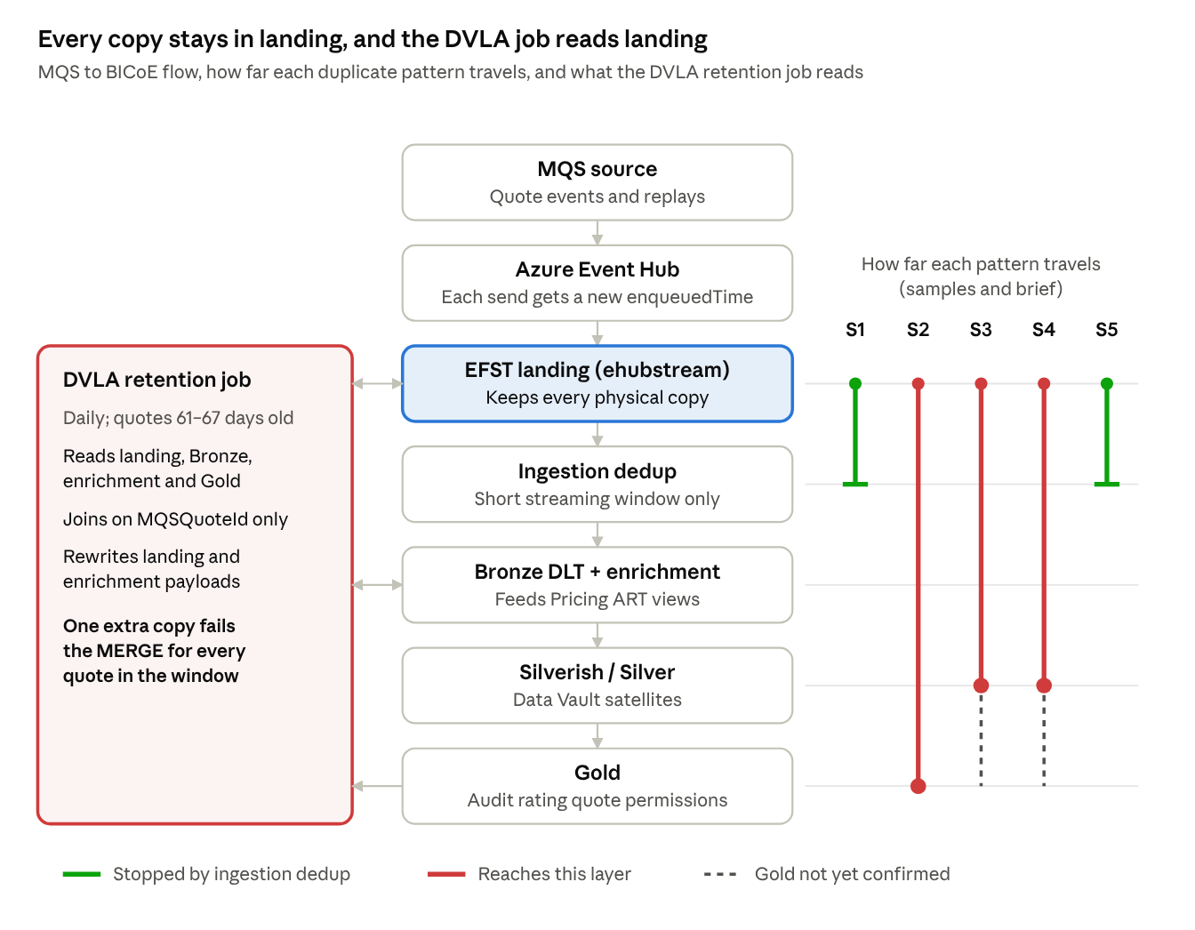
MQS → BICoE data flow · duplicate reach by pattern · DVLA job inputs
S1 and S5 copies are removed by ingestion dedup but stay in landing, and the DVLA job reads landing, so all five patterns can break retention. S2 travels to Gold. S3 and S4 reach Silver, with Gold still unconfirmed.

Layer impact matrix
Layer / consumer | S1 Same-day | S2 Cross-day | S3 Diff quoteStep | S4 Reload | S5 Exact replay
EFST landing (ehubstream) | 10 copies kept | 4 copies kept | Variants kept | Duplicates kept | 2 identical copies kept
Ingestion dedup | Removed | Same-day copy removed; later days pass | Passes | Bypassed | Removed (sample)
Bronze DLT + enrichment | 1 row | 3 rows | Impacted | 2 rows | 1 row
Silverish / Silver | 1 row | 3 rows | Impacted | Impacted | 1 row
Gold | 1 row | 3 rows | To confirm | To confirm | 1 row
Pricing ART views | No impact | Impacted | Impacted | Potential | Potential
Reconciliation | No impact | To confirm | To confirm | Handled by its own dedup | To confirm
DVLA retention | Fails (code) | Fails (code) | Expected to fail | Fails (confirmed) | Fails (confirmed)
Row counts are for one sample quote per scenario (Part D). There is no S3 sample yet, and the S4 sample covers the rating-request path.

Where a control could sit
Control point | Fixes | Strengths | Limits
Source (MQS) | S2, S3, S5 at root | Removes the cause; no BICoE complexity | Depends on MQS delivery; no protection if replays return; cannot fix S4
Ingestion (longer or key-based dedup state) | S2, S5 | Stops copies before Bronze, so Pricing ART is protected too | Long-lived streaming state costs memory; landing still keeps every copy
Silver load (Data Vault satellite keyed on the canonical event) | S2, S5; S3 once the rule exists | The natural Data Vault control: a satellite should not insert a row whose business content is unchanged. Covers all history | Landing and Bronze (and so Pricing ART) still see copies
Consumers (DVLA job, Pricing ART views) | Consumer failures for all five | Fast; independent of upstream; removes the compliance failure now | Duplicates still exist in the data
Load process (batch guard) | S4-type re-loads | Simple; prevents operator re-runs | Covers manual loads only

Recommended layered design
No single control point covers all five patterns, and one generic dedup rule would delete valid S3 data. The recommended design layers four controls:
- Consumers are duplicate-tolerant (now). The DVLA job de-duplicates its own inputs (Part D). Pricing ART confirms or adds view-level filtering.
- Silver enforces the canonical key (permanent). The satellite load inserts a row only when the business content changes for that key. Its change detection (hashdiff) must exclude transport fields such as enqueuedTime and load dates. The S2 sample shows today's satellites insert one row per arrival day, which suggests these fields are currently included (to verify).
- Source corrects behaviour (permanent). MQS explains and stops the ~02:00 UTC replays (S2) and exact resends (S5), and fixes quote-step (S3).
- Ingestion keeps its short-window dedup, plus a batch guard on manual loads. S1 stays handled there, and an S4-type re-load cannot recur.
Architecture principle: no consumer should read landing (ehubstream) as if it were de-duplicated. Landing is a raw, append-only record of every physical delivery.

Part D — Development detail

Production samples traced through each layer
Sample | Quote | Message type | Landing | Bronze | Enrichment | Silverish | Silver | Gold
S1 | MQS-02b5206f… | mqs-quote-request | 10 | 1 | 1 | 1 | 1 | 1
S2 | MQS-59908abc… | mqs-quote-request | 4 | 3 | 3 | 3 | 3 | 3
S4 (assumed) | MQS-8f24e86a… | rating-request | 2 | 2 (dlt_rating_request_v2) | — | — | — | DVLA table: 2
S5 | MQS-a8acfa1c… | mqs-quote-request | 2 | 1 | 1 | 1 | 1 | 1
Tables: Bronze = dlt_quote_request, Enrichment = dlt_raw_enrichments, Silverish = dv_quote_rqst_mtr_athn_mqs_sat, Silver = quote_rqst_mtr_athn_mqs_sat, Gold = dim_audit_rating_quote_permissions, S4 DVLA table = dlt_rating_request_dvla_removed_v2.

S1 — Same-day replay
- Signature: same logical message; enqueuedTime differs by milliseconds; same day.
- Mechanism: all copies fall inside the streaming dedup window, so only one passes to Bronze. Landing keeps every copy.
- Evidence: ten mqs-quote-request copies landed on 26 Sep between 02:00:00.429 and 02:00:00.526, two with identical enqueuedTime. Every layer from Bronze to Gold has one row. Bronze kept the .503 copy, not the earliest, so the survivor rule is not deterministic.
- Fix: no ingestion change. Make the DVLA job tolerant, because it reads landing. Make the survivor deterministic, for example the earliest enqueuedTime.

S2 — Cross-day replay
- Signature: same MQSQuoteId, messageType and EVENT_DTS; new enqueuedTime on a later day.
- Mechanism: the replay arrives after the watermark window has closed, so it is treated as new and flows to Gold. The Silver satellite inserts a row per arrival because LOAD_DT/DWH_ANCHOR_DT differ.
- Evidence: MQS-59908abc… landed four times: 22 Sep 15:25:37.578 and 15:25:41.242, 23 Sep 02:00:04.034, and 25 Sep 02:00:13.607. The second same-day copy was removed. Three rows reached Gold, all sharing QUOTE_MQS_QUOTE_LNK_KEY and RATING_QUOTE_KEY. The replays arrive at about 02:00 UTC, which suggests a scheduled upstream job.
- Fix: key-based control at the Silver load (hashdiff excluding transport fields); MQS stops the replays; clean up the existing Silver and Gold duplicates.

S3 — Same quote and message type, different quoteStep
- Signature: same MQSQuoteId + messageType; quoteStep differs.
- Mechanism: the records are not identical, so no current dedup treats them as copies. Seen in production about 8–30 Sep 2026, after MQS had reported it fixed.
- Evidence: no sample supplied yet.
- Fix: MQS root cause and the valid-record rule first. Do not de-duplicate on MQSQuoteId + messageType alone, because that may delete valid data.

S4 — Historical header-fix reload
- Signature: same source/event content; TimeEnqueued differs slightly; confined to the backfill period.
- Mechanism: the same historical data was loaded into landing twice during the header-fix backfill. This bypassed the replay path the dedup is designed for.
- Evidence (tab name not visible; assumed S4): MQS-8f24e86a… on 6 Aug had two rating-request records, both quoteStep GetQuote, landed 2.7 s apart. Their offsets were out of order (20158653, then 20158046), which fits a separate re-load. Both rows reached dlt_rating_request_v2 and dlt_rating_request_dvla_removed_v2. DVLA retention failure is confirmed.
- Fix: one-off clean-up of DLT, Silverish, Silver and enrichment for the period, a rerun of DVLA retention, and a batch guard on manual loads.

S5 — Exact upstream replay
- Signature: fully identical record, including TimeEnqueued.
- Mechanism: EFST lets the identical copy land. Same-window dedup removes it before Bronze, but the DVLA job reads landing, where both copies remain.
- Evidence: MQS-a8acfa1c… on 7 Oct had two identical mqs-quote-request rows (11:29:04.455). Bronze to Gold each hold one row, and the Pricing view was N/A. DVLA retention failure is confirmed.
- Fix: DVLA job tolerance; MQS stops the resends; an exact replay arriving outside the window would also be caught by the Silver key control.

DVLA retention pipeline: why it fails
The job fails with DELTA_MULTIPLE_SOURCE_ROW_MATCHING_TARGET_ROW_IN_MERGE. Its MERGE source is built from landing (which keeps every copy) and joined on MQSQuoteId alone, so any extra copy of a quote in any input multiplies the source rows.
Step | Target | Source | MERGE key
1 | mqs_athn_mtr.ehubstream | ehubstream (mqs-quote-request) ⨝ dlt_raw_enrichments ⨝ dlt_quote_request ⨝ dim_audit_rating_quote_permissions, all on MQSQuoteId; current_date − 67 to − 61; non-"Athena Motor Sale" | MQSQuoteId + messageType + enqueuedTime
2 | mqs_athn_mtr.dlt_raw_enrichments | tmpDVLARemoved | MQSQuoteId only
Delta MERGE lets one source row update many target rows, but it fails the whole statement when two source rows match one target row. For each landing row, step 1 produces re × qr × dim source rows, where each term is that quote's row count in enrichment, Bronze quote-request and Gold.
Sample | Landing | re | qr | dim | Step 1 source rows | Step 1 | Step 2 (if tmpDVLARemoved = step 1 source)
S1 | 10 (2 identical) | 1 | 1 | 1 | 10 | Fails (identical pair) | Fails (10 per quote)
S2 | 4 | 3 | 3 | 3 | 108 | Fails (27 per target row) | Fails
S3 | ≥ 1 | ≥ 1 | ≥ 2 | ≥ 1 | ≥ 2 per row | Fails | Fails
S5 | 2 identical | 1 | 1 | 1 | 2 identical | Fails | Fails
S4 runs through the rating-request DVLA path (dlt_rating_request_dvla_removed_v2), whose code was not provided. The counts above come from code analysis against the samples and should be verified by running the step 1 source query for these quotes.
Operational consequences:
- The MERGE is all-or-nothing, so one duplicated quote stops retention for every quote in the window.
- The window rolls over 7 days, so the same duplicate fails the job for up to seven consecutive runs.
- A quote whose seven eligible runs all fail never has its DVLA data removed. This is a silent compliance gap that needs a catch-up run.
- Joining on MQSQuoteId alone pairs every landing copy with every enrichment and quote-request copy. Where copies differ (S3), a landing row can be overwritten with another copy's payload.

Corrected DVLA source (sketch)
Reduce each input to one row per quote, keep one source row per merge key, and feed step 2 one row per quote. Exact duplicate rows in the target need no change: one source row updates all of them, which is what retention requires.
-- Step 1 source: one row per (MQSQuoteId, messageType, enqueuedTime)
WITH eh AS (
SELECT * FROM mqs_athn_mtr.ehubstream
WHERE eHubQueuedDatestamp BETWEEN current_date - 67 AND current_date - 61
AND headers.messageType = 'mqs-quote-request'
),
re AS (
SELECT * FROM mqs_athn_mtr.dlt_raw_enrichments
WHERE eHubQueuedDatestamp BETWEEN current_date - 67 AND current_date - 61
QUALIFY row_number() OVER (PARTITION BY headers.MQSQuoteId ORDER BY enqueuedTime DESC) = 1
),
qr AS (
SELECT * FROM mqs_athn_mtr.dlt_quote_request
WHERE eHubQueuedDatestamp BETWEEN current_date - 67 AND current_date - 61
QUALIFY row_number() OVER (PARTITION BY headers.MQSQuoteId ORDER BY enqueuedTime DESC) = 1
),
dim AS (
SELECT DISTINCT MQS_QUOTE_ID
FROM curated_idw_mtr_athn_mqs.dim_audit_rating_quote_permissions
WHERE DWH_DATA_DTS >= current_date - 67 AND DWH_DATA_DTS < current_date - 60
AND LATEST_QUOTE_JOURNEY_DESC <> 'Athena Motor Sale'
)
SELECT eh.headers.MQSQuoteId, eh.headers.messageType, eh.enqueuedTime,
regexp_replace(qr.Payload, '}$', '') || ',"rawEnrichments":' || re.Payload:rawEnrichments || '}' AS Payload
FROM eh
JOIN re ON re.headers.MQSQuoteId = eh.headers.MQSQuoteId
JOIN qr ON qr.headers.MQSQuoteId = eh.headers.MQSQuoteId
JOIN dim ON dim.MQS_QUOTE_ID = eh.headers.MQSQuoteId
QUALIFY row_number() OVER (
PARTITION BY eh.headers.MQSQuoteId, eh.headers.messageType, eh.enqueuedTime
ORDER BY eh.writeTimestamp DESC) = 1;
-- Step 2 source: one row per MQSQuoteId
SELECT * FROM tmpDVLARemoved
QUALIFY row_number() OVER (PARTITION BY MQSQuoteId ORDER BY enqueuedTime DESC) = 1;
Three more changes are needed alongside the SQL:
- Catch-up run: widen the window once to cover every day the job has failed.
- Pre-merge check: log any key with more than one source row, so duplicates are reported instead of failing the job blind.
- S3 caveat: "latest" is a placeholder survivor rule; replace it with the MQS quote-step rule once agreed.

Detection checks (run daily until the permanent fix is live)
Pattern | Check
S1 | Landed rows vs rows passed by ingestion dedup per day; alert on a sustained rise
S2 | Silver keys (QUOTE_MQS_QUOTE_LNK_KEY + EVENT_DTS) with more than one DWH_ANCHOR_DT
S3 | Count of distinct quoteStep per MQSQuoteId + messageType > 1
S4 | Same event content with different TimeEnqueued inside a known load period
S5 | Full-row hash in landing with count > 1
DVLA | Step 1 source rows per merge key > 1 before the MERGE runs

Part E — Decisions, owners and next actions
The blocking dependency is the canonical quote-event key; the DVLA job fix is the most urgent action and depends on nothing else.

Decisions
Decision | Scenarios | Owner(s) | Outcome needed
Prioritise the DVLA job fix and catch-up run | All | Leadership + BICoE Dev | Approval and a date
Define the canonical MQS quote-event key | S2, S5 | MQS + BICoE Architecture | Agreed key / matching rule
Choose the permanent control point (recommended: source fix + Silver key control) | S2, S3, S5 | Architecture + MQS + BICoE Dev | Design decision
Confirm the valid quoteStep rule and why it recurred 8–30 Sep | S3 | MQS | Root cause + valid-record rule
Confirm Pricing ART view sources and filtering | S2–S5 | Pricing ART + BICoE | View-level dedup position
Confirm Gold for S3–S4 and size S2 duplicates already in Gold | S2–S4 | Glenn / Gold owner | Affected rows + clean-up plan
Name an owner for daily duplicate monitoring | All | Leadership | Named owner

Next actions
- ☐ Priority: BICoE applies the DVLA job fix and runs a catch-up over every failed day
- ☐ BICoE + DVLA owner complete the S4 clean-up and prove retention succeeds
- ☐ BICoE proposes the candidate canonical key and the Silver satellite change (hashdiff without transport fields)
- ☐ MQS confirms root cause for S2, S3 and S5, including what runs at about 02:00 UTC daily
- ☐ Glenn sizes the S2 duplicates in dim_audit_rating_quote_permissions and confirms S3–S4
- ☐ Pricing ART confirms view sources and filtering
- ☐ BICoE sets up the daily detection checks in Part D

Evidence still needed
- ☐ An S3 sample (8–30 Sep) with headers[quoteStep] showing differing values
- ☐ Confirmation that the 6 Aug rating-request sample is S4
- ☐ The tmpDVLARemoved definition and the rating-request DVLA job code
- ☐ The current Silver satellite hashdiff columns and the Bronze survivor rule

Source
- BICoE Duplicate Patterns — Leadership & Architecture Decision Brief (provided document); production layer samples and DVLA notebook screenshots (provided 8 Oct 2026).

